NOTICE

Applications in the prescribed Google form are invited from the students who wish to avail fee concession for the academic year 2021-22. The completed form with requisite documents should be submitted by January 18, 2021.
Link to the Google form is:
https://docs.google.com/forms/d/1WZNT26F1EdPsOMNmlIvTCsPBk_xcX8D0MwzbynqZMdE/edit?usp=drivesdk

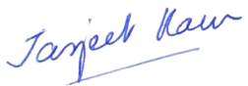
Dr Jasjeet Kaur
Convener,
Fee Concession Committee

January 8, 2022

